|  |  |
| --- | --- |
| **Simple** | **2017** |

**Capabilities covered:**

* Implement Web UI that meets the functional specifications
* Add actions, interactions, business logic using JavaScript (ES6 & TS)
* Develop responsive pages using Material Design, Bootstrap & Media Query

# Basic Tags in HTML

Design a web page exactly as given in the following figure, using the basic HTML tags

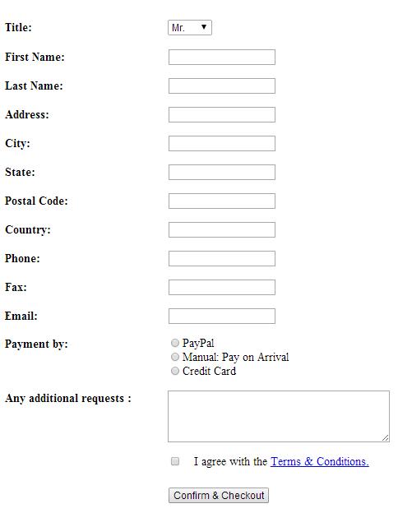

Figure 1: User Details Confirmation and Checkout page

# 2. Design Layout of UI (using table, form, div and span etc.) and make it responsive web applications

Design a web page exactly as given in the following figure, using the form, table, div, span etc.

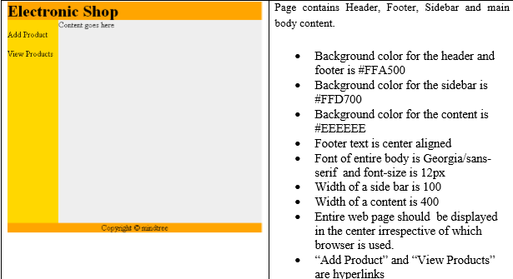Figure 2: Electric Shop Home page

# 3. Validate User Input Using JavaScript

Refer the web page given below and write JavaScript code to validate the user input as listed below

1. Text boxes should not remain blank
2. Postal code should have exactly six digits, such as
3. Mail id should be validated



Figure 3: User Details Confirmation and Checkout page

# 4. Handling User Events Using JavaScript

Write JavaScript code to add or subtract or multiply or divide two numbers, entered into two text boxes, as in the web page given below.

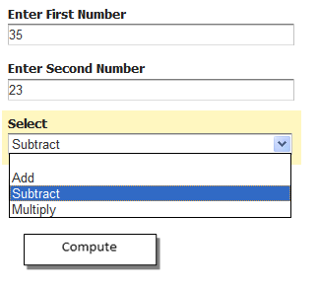

Figure 4: Calculation Page

# 5. Applying CSS to Web Page

Apply CSS to design the web page, as given in the figure below

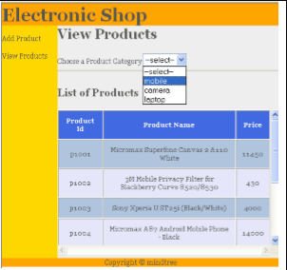

Figure 5: Electric Shop View Products Page